CHAPTER NO 15

MICROSOFT POWER POINT 2007

WHAT IS POWER POINT PRESENTATION?
PowerPoint is a presentation software program that is part of the Microsoft Office package.
PowerPoint uses a graphical approach to presentations in the form of slide shows that accompany the oral delivery of the topic. This program is widely used in business and classrooms and is an effective tool when used for training purposes.
PowerPoint is one of the simplest computer programs to learn. It is the easy and good program used worldwide for presentations. Anyone can create stunning presentations that look like they were designed by a professional.
It is easy to customize presentations with your company logo and to dazzle your audience by using one of the many design templates that come with the programs. Many more free templates are available online from Microsoft and a host of other websites.
In addition to an on screen slide show, PowerPoint has printing options that allow the presenter to provide handouts and outlines for the audience as well as notes pages for the speaker to refer to during the presentation.
WHAT IS PRESENTATION?
A presentation is a collection of data and information that is to be delivered to a specific audience. A PowerPoint presentation is a collection of electronic slides that can have text, pictures, graphics, tables, sound and video. This collection can run automatically or can be controlled by a presenter.

GETTING START
To start MS Power Point click on the Start Menu on the bottom left corner of your desktop and select Start→ All Programs→ Microsoft Office →Microsoft Office Power Point 2007.

SCREEN LAYOUT

Getting started with PowerPoint 2007 will notice that there are many features that you’ll be able to utilize for presentation. There are three features that you should remember as you work within PowerPoint 2007:
- The Microsoft Office Button,
- The Quick Access Toolbar,
- The Ribbon.
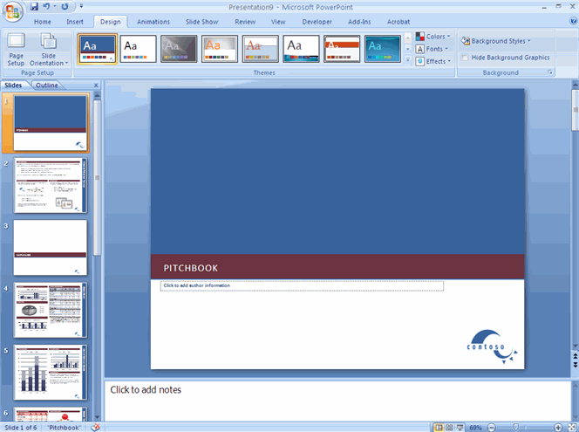
The function of these features will be more fully explored below.
MICROSOFT OFFICE BUTTON
The Microsoft Office Button performs many of the functions that were located in the File menu of older versions of PowerPoint. This button allows you to create a new presentation, Open an existing presentation, save and save as, print, send, or close.
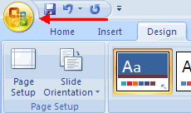

RIBBON
The ribbon is the panel at the top portion of the document it has seven tabs: Home, Insert, Design, Animations, Slide Show, Review and View. Each tab is divided into groups. The groups are logical collections of features designed to perform function that you will utilize in developing or editing your PowerPoint slides.
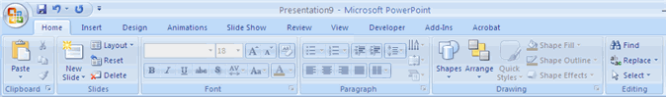
Commonly used features are displayed on the Ribbon, to view additional features within each group, click on the arrow at the bottom right of each group.

HOME: | Clipboard, Slides, Font, Paragraph, Drawing, and Editing
INSERT: | Tables, Illustrations, Links, Text, and Media Clips.
DESIGN: | Page Setup, Themes, Background.
ANIMATIONS: | Preview, Animations, Transition to this Slide
SLIDE SHOW: | Start Slide Show, Set Up, Monitors.
REVIEW: | Proofing, Comments, Protect.
VIEW: | Presentation Views, Show/Hide, Zoom, Window, Macros

QUICK ACCESS TOOLBAR
The quick access toolbar is a customizable toolbar that contains commands that you may want to use. You can place the quick access toolbar above or below the ribbon. To change the location of the quick access toolbar, click on the arrow at the end of the toolbar and click Show Below the Ribbon.
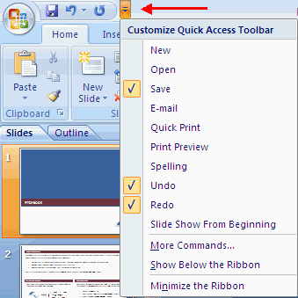
MINI TOOLBAR
A new feature in Office 2007 is the Mini Toolbar. This is a floating toolbar that is displayed when you select text or right-click text. It displays common formatting tools, such as Bold, Italics, Fonts, Font Size and Font Color.
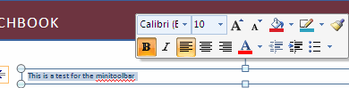

NAVIGATION
Navigation through the slides can be accomplished through the Slide Navigation menu on the left side of the screen. Also, an outline appears from materials that have been entered in the presentation. To access the outline, click the outline tab.
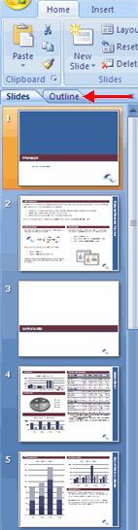
SLIDE VIEWS
Presentations can be viewed in a variety of manners. On the View tab, the Presentation Views group allows you to view the slides as Normal, Slide Sorter, Notes Page, Slide Show, Slide Master, Handout Master, and Notes Master.
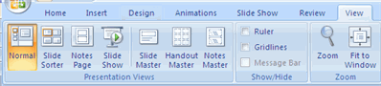

HOW TO MAKE NEW PRESENTATION
You can start a new presentation from a blank slide, a template, existing presentations, or a Word outline. To create a new presentation from a blank slide:
- Click the Microsoft Office Button 
- Click New
- Click Blank Presentation
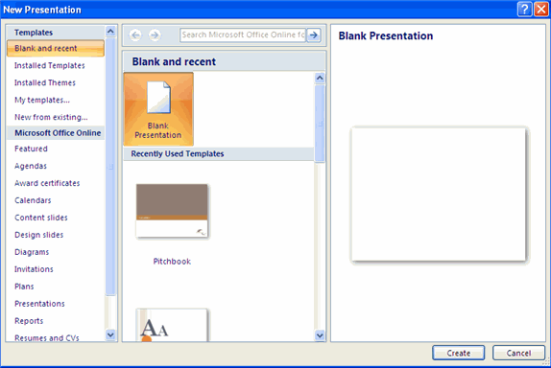
To create a new presentation from a template:
- Click the Microsoft Office Button
- Click New
- Click Installed Templates or Browse through Microsoft Office Online Templates
- Click the template you choose
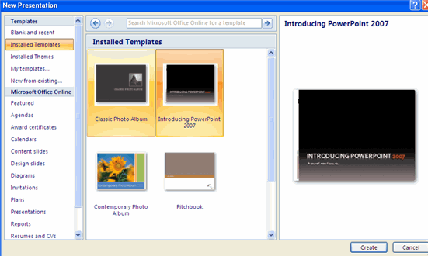
To create a new presentation from an existing presentation:
- Click the Microsoft Office Button
- Click New
- Click New from Existing
- Browse to and click the presentation
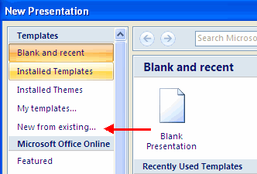
To create a new presentation from a Word outline:
- Click the slide where you would like the outline to begin
- Click New Slide on the Home tab
- Click Slides from Outline
- Browse and click the Word Document that contains the outline
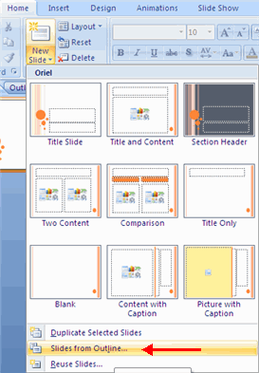

SAVE A PRESENTATION
When you save a presentation, you have two choices: Save or Save As. To save a document:
- Click the Microsoft Office Button
- Click Save
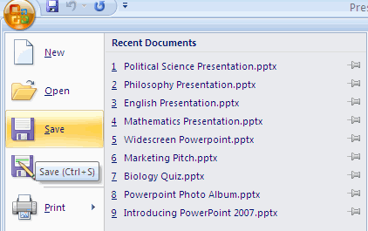
You may need to use the Save As feature when you need to save a presentation under a different name or to save it for earlier versions of PowerPoint. Remember that older versions of PowerPoint will not be able to open PowerPoint 2007 presentation unless you save it as a PowerPoint 97-2003 Format. To use the Save As feature:
- Click the Microsoft Office Button
- Click Save As
- Type in the name for the Presentation
- In the Save as Type box, choose Excel 97-2003 Presentation
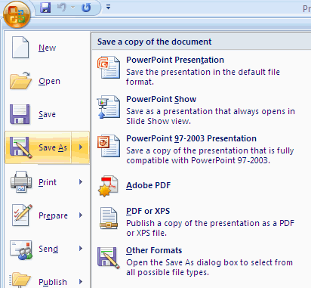

ADD SLIDES
There are several choices when you want to add a new slide to the presentation: Office Themes, Duplicate Selected Slide, or Reuse Slides.
To create a new slide from Office Themes:
- Select the slide immediately BEFORE where you want the new slide
- Click the New Slide button on the Home tab
- Click the slide choice that fits your material
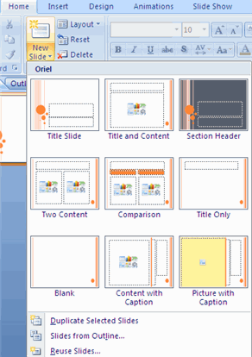

To create a slide as a duplicate of a slide in the presentation:
- Select the slide to duplicate
- Click the New Slide button on the Home tab
- Click Duplicate Selected Slides

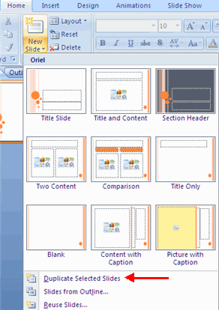

To create a new slide from another presentation:
- Select the slide immediately BEFORE where you want the new slide
- Click the New Slide button on the Home tab
- Click Reuse Slides
- Click Browse
- Click Browse File
- Locate the slide show and click on the slide to import
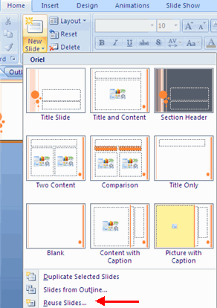

THEMES
Themes are design templates that can be applied to an entire presentation that allows for consistency throughout the presentation. To add a theme to a presentation:
- Click the Design tab
- Choose one of the displayed Themes or click the Galleries button.
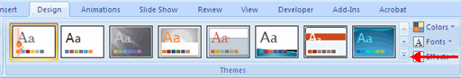
To apply new colors to a theme:
- Click the Colors drop down arrow
- Choose a color set or click Create New Theme Colors
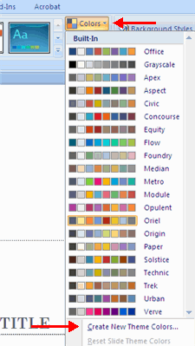
To change the background style of a theme
- Click the Background Styles button on the Design tab
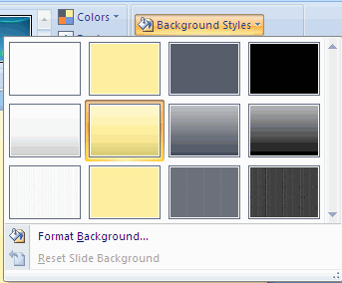

ENTER TEXT
To enter text:
- Select the slide where you want the text
- Click in a Textbox to add text
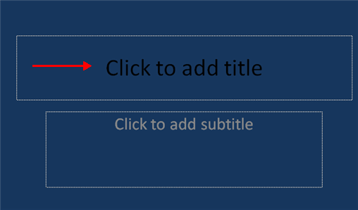
To add a text box:
- Select the slide where you want to place the text box
- On the Insert tab, click Text Box
- Click on the slide and drag the cursor to expand the text box
- Type in the text
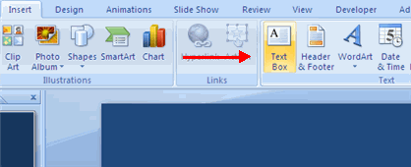

SELECT TEXT
To select the text:
- Highlight the text
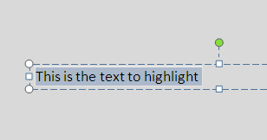

COPY AND PASTE
To copy and paste data:
- Select the item(s) that you wish to copy
- On the Clipboard Group of the Home Tab, click Copy
- Select the item(s) where you would like to copy the data
- On the Clipboard Group of the Home Tab, click Paste
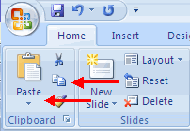

CUT AND PASTE
To cut and paste data:
- Select the item(s) that you wish to copy
- On the Clipboard Group of the Home Tab, click Cut
- Select the items(s) where you would like to copy the data
- On the Clipboard Group of the Home Tab, click Paste
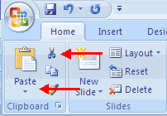

UNDO AND REDO
To undo or redo your most recent actions:
- On the Quick Access Toolbar
- Click Undo or Redo
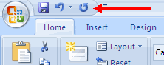
SPELL CHECK
To check the spelling in a presentation:
- Click the Review tab
- Click the Spelling button
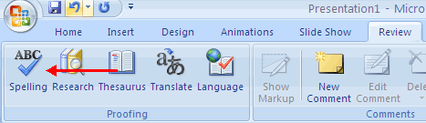

CHANGE FONT TYPEFACE AND SIZE
To change the font typeface:
- Click the arrow next to the font name and choose a font.
- Remember that you can preview how the new font will look by highlighting the text, and hovering over the new font typeface.
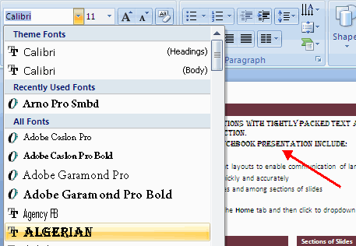

To change the font size:
- Click the arrow next to the font size and choose the appropriate size, or
- Click the increase or decrease font size buttons.
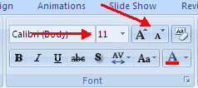

FONT STYLES AND EFFECTS
Font styles are predefined formatting options that are used to emphasize text. They include: Bold, Italic, and Underline. To add these to text:
- Select the text and click the Font Styles included on the Font group of the Home tab or
- Select the text and right click to display the font tools
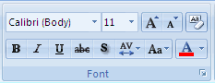

CHANGE TEXT COLOR
To change the text color:
- Select the text and click the Colors button included on the Font Group of the Ribbon, or
- Highlight the text and right click and choose the colors tool.
- Select the color by clicking the down arrow next to the font color button.
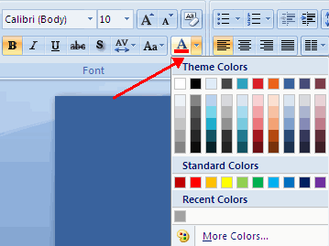

WORDART
WordArt are styles that can be applied to text to create a visual effect. To apply Word Art:
- Select the text
- Click the Insert tab
- Click the WordArt button
- Choose the WordArt
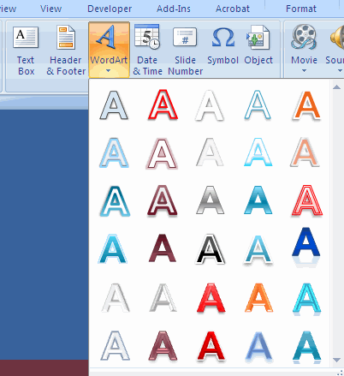

To modify the styles of WordArt
- Select the WordArt
- Click the Format tab for the Drawing Tools
- Click the WordArt Fill button, the WordArt Outline button, or the Text Effects button
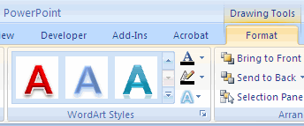

CHANGE PARAGRAPH ALIGNMENT
The paragraph alignment allows you to set how you want text to appear. To change the alignment:
- Click the Home Tab
- Choose the appropriate button for alignment on the Paragraph Group.
  - Align Left: the text is aligned with your left margin
  - Center: The text is centered within your margins
  - Align Right: Aligns text with the right margin
  - Justify: Aligns text to both the left and right margins.
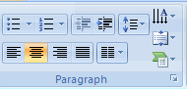

INDENT PARAGRAPHS
To indent paragraphs, you can do the following:
- Click the Indent buttons to control the indent.
- Click the Indent button repeated times to increase the size of the indent.
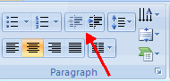

TEXT DIRECTION
To change the text direction:
- Select the text
- Click the Text Direction button on the Home tab
- Click the selection
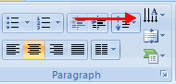

RESIZE A TEXTBOX
To resize a textbox:
- Click on the textbox
- Click the corner of the box and drag the cursor to the desired size
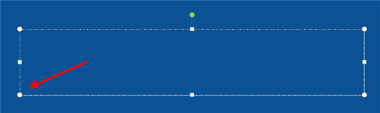

BULLETED AND NUMBERED LISTS
Bulleted lists have bullet points, numbered lists have numbers, and outline lists combine numbers and letters depending on the organization of the list.
To add a list to existing text:
- Select the text you wish to make a list
- Click the Bulleted or Numbered Lists button
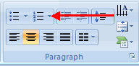
To create a new list:
- Place your cursor where you want the list in the document
- Click the Bulleted or Numbered Lists button
- Begin typing

NESTED LISTS
A nested list is list with several levels of indented text. To create a nested list:
- Create your list following the directions above
- Click the Increase or Decrease Indent button
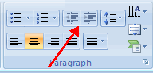
FORMATTING LISTS
The bullet image and numbering format can be changed by using the Bullets or Numbering dialog box.
- Select the entire list to change all the bullets or numbers, or
Place the cursor on one line within the list to change a single bullet.
- Click the arrow next to the bulleted or numbered list and choose a bullet or numbering style.
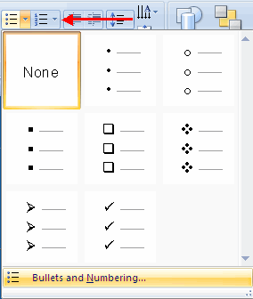

ADDING VIDEO
Video clips can be added to the presentation. To add a video clip:
- Click the Movie button on the Insert tab
- Choose Movie from File or Movie from Clip Organizer
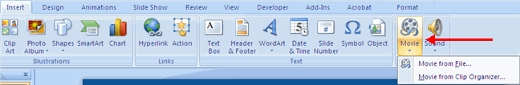
To edit the video options:
- Click the movie icon
- Click the Format tab
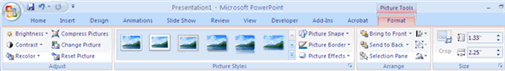

ADDING AUDIO
Audio clips can be added to the presentation. To add an audio clip:
- Click the Audio button on the Insert tab
- Choose Sound from File, Sound from Clip Organizer, Play CD Audio Track, or Record Sound
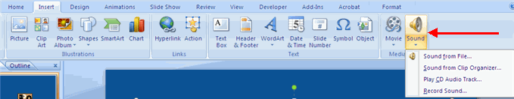
To edit the audio options:
- Click the audio icon
- Click the Format tab
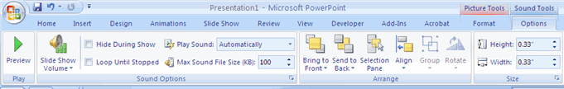

ADDING PICTURE
To add a picture:
- Click the Insert Tab
- Click the Picture Button
- Browse to the picture from your files
- Click the name of the picture
- Click insert
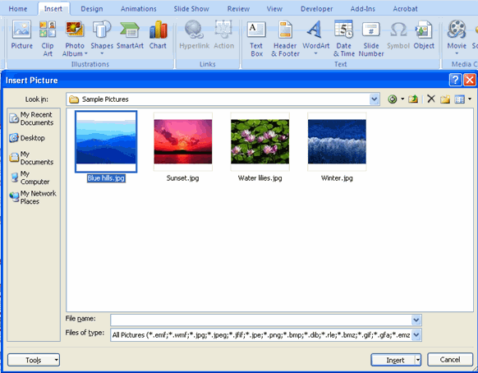
- To move the graphic, click it and drag it to where you want it

ADDING CLIP ART
To add Clip Art:
- Click the Insert Tab
- Click the Clip Art Button
- Search for the clip art using the search Clip Art dialog box
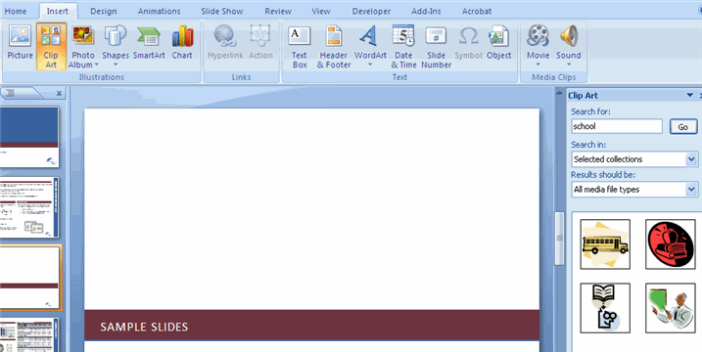
- Click the clip art
- To move the graphic, click it and drag it to where you want it

EDITING PICTURES AND CLIP ART
When you add a graphic to the presentation, an additional Tab appears on the Ribbon. The Format Tab allows you to format the pictures and graphics. This tab has four groups:
Adjust: Controls the picture brightness, contrast, and colors
Picture Style: Allows you to place a frame or border around the picture and add effects
Arrange: Controls the alignment and rotation of the picture
Size: Cropping and size of graphic
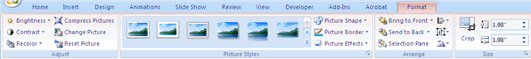

ADDING A SHAPE
To add Shapes:
- Click the Insert Tab
- Click the Shapes Button
- Click the shape you choose
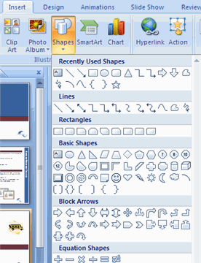
- Click the Slide
- Drag the cursor to expand the Shape
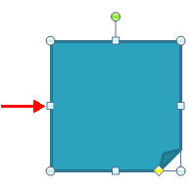
To format the shapes:
- Click the Shape
- Click the Format tab
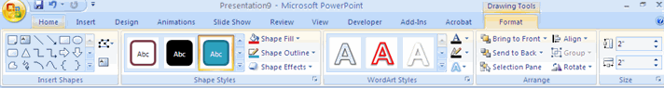

ADDING SMARTART
SmartArt is a feature in Office 2007 that allows you to choose from a variety of graphics, including flow charts, lists, cycles, and processes. To add SmartArt:
- Click the Insert Tab
- Click the SmartArt Button
- Click the SmartArt you choose
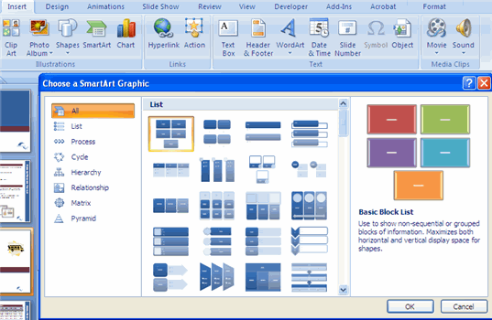
- Click the SmartArt
- Drag it to the desired location in the slide

CREATE A TABLE
To create a table:
- Place the cursor on the page where you want the new table
- Click the Insert Tab of the Ribbon
- Click the Tables Button on the Tables Group. You can create a table one of four ways:
  - Highlight the number of row and columns
  - Click Insert Table and enter the number of rows and columns
  - Click the Draw Table, create your table by clicking and entering the rows and columns
  - Click Excel Spreadsheet and enter data
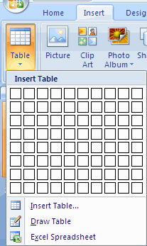

ENTER DATA IN A TABLE
Place the cursor in the cell where you wish to enter the information. Begin typing.
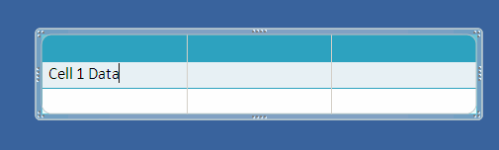

MODIFY THE TABLE STRUCTURE AND FORMAT A TABLE
To modify the structure of a table:
- Click the table and notice that you have two new tabs on the Ribbon: Design and Layout. These pertain to the table design and layout.
On the Design Tab, you can choose:
- Table Style Options
- Table Styles
- Draw Borders
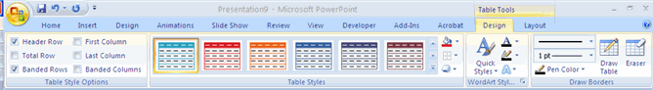
To format a table, click the table and then click the Layout Tab on the Ribbon. This Layout tab allows you to:
- View Gridlines and Properties (from the Table Group)
- Insert Rows and Columns (from the Rows & Columns Group)
- Delete the Table, Rows and/or Columns (from the Rows & Columns Group)
- Merge or Split Cells (from the Merge Group)
- Increase and decrease cell size (Cell Size Group)
- Align text within the cells and change text directions (Alignment Group)
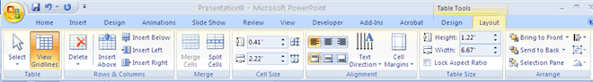

HOW TO CREATE CHARTS?
Charts allow you to present information contained in the worksheet in a graphic format. PowerPoint offers many types of charts including: Column, Line, Pie, Bar, Area, Scatter and more. To view the charts available click the Insert Tab on the Ribbon.
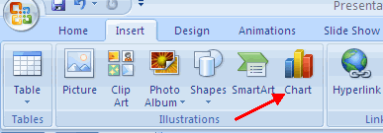
To create a chart:
- Click the Insert tab on the ribbon
- Click the type of Chart you want to create
- Insert the Data and Labels
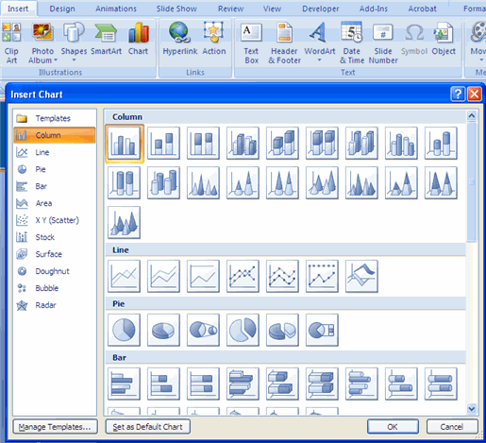

SLIDE TRANSITIONS
Transitions are effects that are in place when you switch from one slide to the next. To add slide transitions:
- Select the slide that you want to transition
- Click the Animations tab
- Choose the appropriate animation or click the Transition dialog box
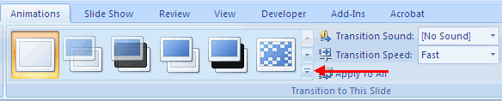
To adjust slide transitions:
- Add sound by clicking the arrow next to Transition Sound
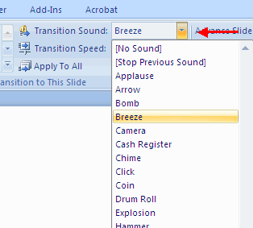
- Modify the transition speed by clicking the arrow next to Transition Speed
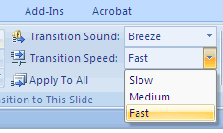
To apply the transition to all slides:
- Click the Apply to All button on the Animations tab
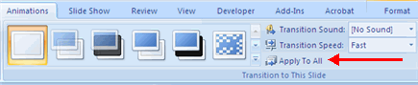
To select how to advance a slide:
- Choose to Advance on Mouse Click, or
- Automatically after a set number of seconds
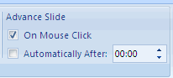

SLIDE ANIMATION
Slide animation effects are predefined special effects that you can add to objects on a slide. To apply an animation effect:
- Select the object
- Click the Animations tab on the Ribbon
- Click Custom Animation
- Click Add Effect
- Choose the appropriate effect
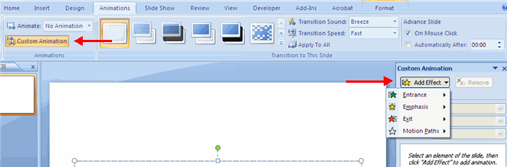

ANIMATION PREVIEW
To preview the animation on a slide:
- Click the Preview button on the Animations tab
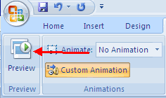

SLIDE SHOW OPTIONS
The Slide Show tab of the ribbon contains many options for the slide show. These options include:
- Preview the slide show from the beginning
- Preview the slide show from the current slide
- Set up Slide Show
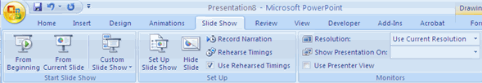

SET UP SLIDE SHOW
This option allows you to set preferences for how the slide show will be presented. The options include:
- Whether the show will run automatically or will be presented by a speaker
- The looping options
- Narration options
- Monitor resolutions
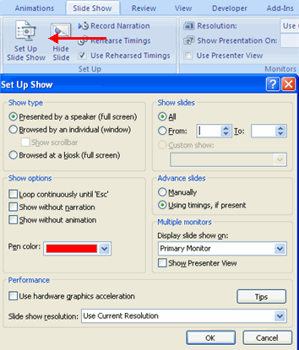

PRINT A PRESENTATION
There are many options for printing a presentation. They are:
- Slides: These are slides that you would see if you were showing the presentation, one slide per page
- Handouts: 1, 2, 3, 4, 6 or 9 per page, this option allows for more slides per page
- Notes Page: This includes the slides and the speaker notes
- Outline View: This will print the outline of the presentation
To access the print options:
- Click the Microsoft Office Button
- Click Print
- In the Print Dialog Box, click the arrow next to Print what
- Choose the format and click OK to print
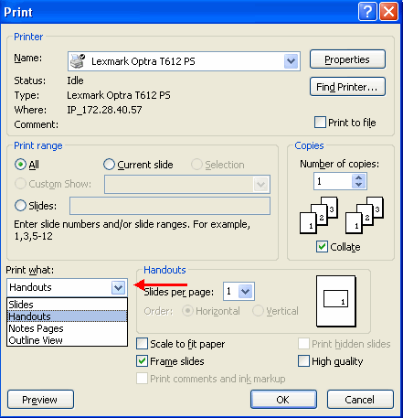

To print preview:
- Click the Microsoft Office Button
- Place the cursor over Print
- Click Print Preview
- Click the arrow next to Print What to change print options
- To print from Print Preview, click Print
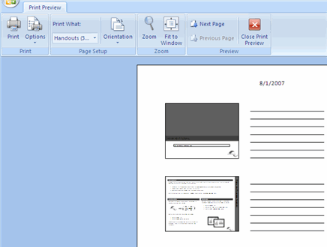
To Exit Print Preview:
- Click the Close Print Preview button
